**Learner Details**

* **Name:Nikhil k**
* **Enrollment Number: su625mr004**
* **Batch / Class: Mern Stack**
* **Assignment: Fruit list**
* **Date of Submission: 21-07-2025**

**Problem Solving Activity 1.1**

**1. Program Statement**

This program creates and manages a list of my favourite fruits using JavaScript arrays. It allows

me to display the list, add a new fruit, remove one, sort them alphabetically, and count the total

number. The program runs entirely in the browser’s console.

**2. Algorithm**

• Create an array called fruits with 5 fruit names.

• Use a loop to print each fruit in the array.

• Add a new fruit at the end using .push().

• Remove the first fruit using .shift().

• Sort the array alphabetically using .sort().

• Print the total number of fruits using .length.

**3. Pseudocode**

Start

Initialize array fruits with 5 fruit names

For each fruit in the array:

Print the fruit

Add "Pineapple" to the end using push()

Print the updated array

Remove the first fruit using shift()

Print the updated array

Sort the array alphabetically using sort()

Print the sorted array

Print the number of fruits using length

End

**4. Program Code**

<!DOCTYPE html>

<html lang="en">

<head>

<meta charset="UTF-8">

<meta name="viewport" content="width=device-width, initial-scale=1.0">

<title>Fruits</title>

</head>

<body>

<script>

let fruits = ["Apple", "Banana", "Grapes", "Mango", "Orange"]

console.log("Display an array named fruits in the console using a loop are as follows :");

for (let i = 0; i < fruits.length; i++) {

console.log(fruits[i]);

}

// Adding one more fruit to the end of the array using push() and displaying the updated list.

fruits.push("Pineapple");

console.log("After performing push operation:", fruits);

// Removing the first fruit from the array using shift() and displaying the updated list.

fruits.shift();

console.log("After performing shift operation:", fruits);

// Sorting the fruits in alphabetical order and displaying them.

fruits.sort();

console.log("Fruits in 'Sorted order are' as follows:", fruits);

// Printing how many fruits are currently in the list using length.

console.log("Total fruits count are:", fruits.length);

</script>

</body>

</html>

**6. Screenshots of Output**

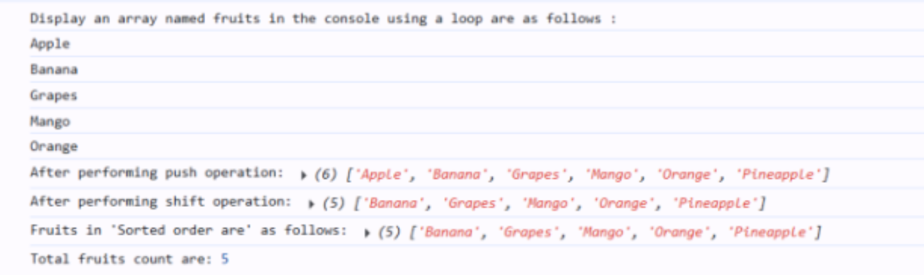

**7. Observation / Reflection**

• I learned how to structure a webpage for an online restaurant menu using HTML and interactive JavaScript functions.

• Implementing filterItems() helped me understand DOM manipulation for showing/hiding elements.

• Updating the cart count dynamically taught me how to modify webpage content in real-time.